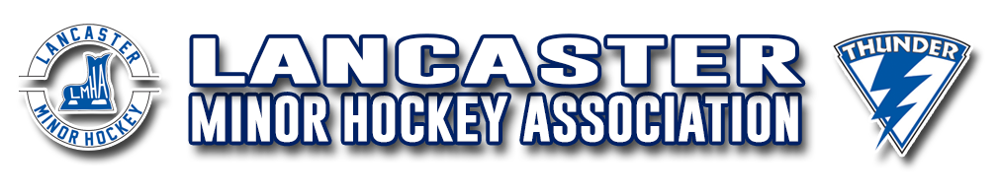

**LMHA** **Jersey Loan Agreement**

LMHA purchases jerseys to loan to players, in order to assign jerseys each season, every member.

**Is Required to:**

* Complete this Jersey Loan Agreement and sign the Jersey sign out sheet, before jerseys are handed out.
* Use a garment bag to carry jerseys to and from Arenas.
* Parents/Guardians/Players are responsible for the safekeeping of their jerseys. They must always remain in their possession and should ONLY be used for Minor Hockey Games and LMHA sanctioned events,**not** to be worn at practices.
* The jerseys must not be abused or altered (unless LMHA approved) in any way and should be cleaned on a regular basis and hung to dry. \**Do not place jerseys in the dryer*\*
* LMHA allows name bars and “C’s” & “A’s”, to be sewn on. Any name bar or letters ***must*** be removed without damage to the jersey before they are returned. If they are not removed there will be a $50.00 charge per jersey. **Any** damage including removing the letters or the name bar will result in a $100.00 charge per jersey.
* Jerseys must be returned clean or a dry-cleaning fee of $50.00 per jersey will be applied.

**Player Name: ________________________________________**

**Team Name: _________________________________________**

**Parent/Guardian Name: ___________________________________**

**Jersey #______ Size_________**

By signing below, I hereby acknowledge receipt of the above hockey jerseys, and the value thereof ($100.00 each). I further agree to be responsible for the safekeeping of said jerseys, and to surrender them by the date provided by LMHA. I agree not to remove the jerseys from my custody without the consent of LMHA, and to ensure they are not abused or altered in any way not permitted by LMHA. I further agree to regularly clean the jerseys and always place them in a garment bag. In the event the jerseys are lost or stolen, or for any reason cannot be delivered to LMHA upon request, I agree to pay the value thereof approved by the LMHA Equipment Manager ($100.00 for each jersey).

LMHA issued jerseys are the **ONLY** jerseys to be worn in games.

**Parent/Guardian Signature**________________________________________

**Date_______________________________**

*\*This agreement* ***must*** *be signed and returned along with the Jersey sign out sheet, and returned by October 30th\**