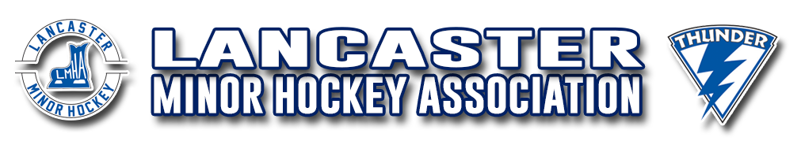

**PARENT CODE OF CONDUCT**

By the very nature of the sport, hockey is a fast paced and physical game. From time to time, emotions will run high and poor judgment may occur. As parents, guardians and coaches it is our responsibility to encourage our children/players to play by the rules and at all times be respectful. We must remember that children learn best by example. When we show positive attitudes towards the game, other players, coaches, as well as referees, our children will benefit and follow our lead. As a Parent or Guardian, I acknowledge the following rules that form this Code of Conduct:

● Participation in the Lancaster Minor Hockey Association is a privilege, **not** a right.

● Physical abuse or threatening behavior towards other parents, coaches, officials, players or members of the LMHA Executive/Board will not be tolerated.

● Foul language or other forms of verbal abuse or harassment towards other parents, coaches, officials, players will not be tolerated.

● Respect and adhere to all ideals, policies and rules determined by HNB and Hockey Canada, and Lancaster Minor Hockey Association.

● Respect the rules of the game, opponents, coaches and officials.

● Maintain self-control at all times.

● Encourage my player to attend as many games and practices as reasonably possible and to notify the coach ahead of time and in a timely manner in regard to absences.

● Respect the facilities, whether home or away, in which my player is privileged enough to play.

● Remember that my player and family members attending the games/practices represent LMHA and are expected to act in an appropriate manner.

● Show respect for the decision, judgment and authority of the officials and timekeepers. Players, coaches, and referees are all human and they may make mistakes too.

● Show respect for the feelings and abilities of my player, my players team-mates and the players on the opposing team.

● Refrain from demonstrations of frustration and anger at all times, keep in mind, this is youth hockey.

● Refrain from expressing your opinions of coaches, players and parents from both my player’s team and the opposing team in front of my player or anyone else’s.

● Wait 24 hours as a cool down period before approaching a coach or member of the team staff as well as the LMHA Executive and Board Members with a concern or complaint.

● Read the Social Media and Networking Policy (Link below) <https://www.hnb.ca/images/hnb/pdf/Hockey_New_Brunswick_Social_Media_and_Networking_Policy.pdf>.

This policy outlines how parents/guardians should voice any concerns privately, not in public, nor on a public forum (e.g. Facebook, Twitter, or any other social media platform or TeamSnap).

Lancaster Minor Hockey Association PARENT/GUARDIAN CODE OF CONDUCT AGREEMENT.

As a parent or guardian of ________________________________, a participant in LMHA, I agree to adhere to the LMHA Hockey Parent/Guardian Code of Conduct. I fully understand that Violation of this Code of Conduct may result in Disciplinary Action.

I understand failure to sign this PARENT/GUARDIAN CODE OF CONDUCT will result in my player not being eligible for play with LMHA HOCKEY.

I, ___________________________________ acknowledge having read this agreement and irrevocably agree to be bound by it for the duration of the season. This agreement applies to all LMHA HOCKEY affiliated events and teams.

Parent/Guardian Name: _____________________________

Signature: _____________________________

Dated: _____________________________

***\*\*Must be returned by October 30th\*\****